

TRIBHUVAN UNIVERSITY
FACULTY OF HUMANITIES AND SOCIAL SCIENCE

A Project Report On Scripting Language
"Doctor Appointment Management System"

Submitted to Department of Computer Application National College of Computer Studies

Submitted By:

Mandira

Shrestha
Roll: 9
28/04/2024

Under the Supervision of

Teksan Gharti Magar

………

ABSTRACT
The Doctor Appointment Management System (DAMS) is a software solution designed to the process of scheduling and managing appointments between patients and healthcare providers. It deals with the collection of patient’s information, diagnosis detail etc. Traditionally, it was done manually. The main objective of a Doctor Appointment Management System (DAMS) is to process of scheduling and managing appointments between patients and healthcare providers. Waterfall methodology is used for the development process. These platforms can be used from anywhere at any time hence saving a lot of time for the user. For the development of this project we use css, js, php, mysql tools. Overall, the Doctor Appointment Management System aims to improve the efficiency of healthcare practices by streamlining the appointment scheduling process, enhancing patient engagement, and enabling healthcare providers to deliver more personalized care.

ACKNOWLEDGEMENT
I would like to thank my supervisor Mr. Teksan Gharti Magar for his valuable guidance who gave me great encouragement for this work and helpful suggestions.
I would also like to thank our Vice Principle sir, Mr. Santosh Maskey who monitored, guided and motivated us throughout all the phases of this project. I appreciate the support from all the supervisors, friends and family to help make this project successfully.
Mandira Shrestha

Table of Contents

ABSTRACT i
ACKNOWLEDGEMENT ii
LIST OF FIGURES v
LIST OF TABLES vii
LIST OF ABBREVIATIONS vii
Chapter 1: Introduction 1
  - Introduction 1
  - Problem Statement 1
  - Objectives 1
  - Scope and Limitation 2
  - Report Organization 2
    - Introduction 2
    - Background study and literature review 2
    - System analysis and design 2
    - Implementation and testing 2
    - Conclusion and future recommendation 2
Chapter 2: Background Study 3
  - Background Study 3
    - Study of existing system 3
Chapter 3: System Analysis and Design 4
  - System Analysis 4
    - Requirement Identification 4
    - Feasibility Study 4
    - Data Modeling 6
    - Process Modeling 7
    - Use-Case Diagram for User and Admin: 8
    - Flow Chart for Admin 9
  - System Design 10
    - Architectural Design 10
    - Database design schema 11
Chapter 4: Implementation and testing 12
  - Implementation 12
    - Tools Used 12
    - Implementation details of modules 12
  - Testing 13
    - Testing cases for unit testing 13
    - Testing case for System testing 15
Chapter 5: Conclusion and future recommendation 17
  - Lesson learnt/ outcome 17
  - Conclusion 17
  - Future Recommendations 17
Appendices 18
References 23

LIST OF FIGURES

Figures | Page
Fig 3.1: Waterfall model. | 4
Fig 3.2: ER-Diagram of DAMS | 6
Fig 3.3: Concept diagram of DAMS | 7
Fig 3.4: DFD level-0 of DAMS | 7
Fig 3.5: Use case diagram of DAMS. | 8
Fig 3.6: Flow Chart for Admin | 9
Fig 3.7: Architectural design of DAMS | 10
Fig 1: Home Page | 18
Fig 2: About us Page | 19
Fig 3: Booking an Appointment Page | 19
Fig 4: Checking Appointment Page | 20
Fig 5: Contact Page | 20
Fig 6: Doctor signup Page | 21
Fig 7: Admin Home Page | 21
Fig 8: Appointment Detail Page | 22

LIST OF TABLES

Table | Page
Table 3.1: tblappointment | 11
Table 3.2: tbldoctor | 11
Table 3.3: tblspecialization | 11
Table 3.4: tblpage | 11
Table 4.1: Test cases of unit testing for login and logout operation | 13
Table 4.2: Test cases of unit testing for admin operation | 14
Table 4.3: Test cases of System testing | 16

LIST OF ABBREVIATIONS

HTML | Hyper Text Markup Language
CSS | Cascading Style Sheet
PHP | PHP Hypertext Preprocessor
MySql | Database Management System
Apache | Server
SQL | Structured Query Language

Introduction

Chapter 1: Introduction

A doctor appointment management system is an online system that allows patients to easily book their appointment at a particular clinic related to their health issue. Such as Dental, Injury, Metal health, Muscle strain, Obesity, Arthritis, Asthma, etc. world.
Many people are suffering from different diseases (around 95% of the world’s population). Each week, many people from those book appointments to a nearby doctor to get the treatment. It’s a booking form with different fields that ask the patient to fill it up and submit it to consider it as an appointment. This system saves a lot of time for the patient as well as you. Plus, with this, you can manage different aspects of the business pretty well.

Problem Statement
The current method of scheduling and managing appointments between patients and healthcare providers is inefficient and outdated. Manual processes, such as phone calls and paper-based systems, lead to long wait times, scheduling errors, missed appointments, and poor clinic efficiency. There is a clear need for a modern solution that streamlines the appointment booking process, reduces administrative burden, minimizes missed appointments, and optimizes clinic workflows.

Objectives
The main objective of doctor appointment management system is:

    - To provide a platform that allows users to scheduling and managing appointments between patients and healthcare providers.
    - To create web base online doctor appointment system.
    - Track and find out the specialization of doctor and manage all patient’s related information.
    - Doctor can also update profile, change the password and recover the password.
    - Doctor can view the appointment details in a particular period.

Scope and Limitation
The system allows user to book appointments with healthcare providers easily and conveniently. user receive automated reminders before their appointments, reducing the likelihood of missed appointments.
The main drawback of this project is the effectiveness of the system may be limited by technical issues such as internet connectivity or software compatibility.

Report Organization

Introduction
Chapter one introduces the concept of this project. It describes the problems that has been existing and how its objective can tackle it. It also presents the scope and limitations of the project.

Background study and literature review
This chapter focuses on the basic ideology of how this project will be build. It traces out the study of different platforms and their workings.

System analysis and design
This chapter describes the requirements gathering, feasibility study, and designing of the project. It includes diagrams, functionality analysis, requirement gathering technique and process model.

Implementation and testing
This chapter is designed to give information about how the project has been implemented, what kind of software and tools has been used and the type of testing that the project has gone through.

Conclusion and future recommendation
This chapter includes the possible outcome of this project, conclusion and future recommendations.

Chapter 2: Background Study

Background Study
It is the study of history of doctor appointment management system, how it emerged and when did it started gaining popularity. The existing systems has been studies as the background study for this project.

Study of existing system
Many doctor appointment management system websites were visited for the purpose of system study. These websites includes YouTube (1), www.irejournals.com (3) etc. These websites provide immense features which can be both easy to use and learn. These websites allow user to view the welcome page of the web application and can send the appointment request. The doctor views the appointment details and they have also the right to change application status according to the current status. These website provide the doctor can briefly view the total number of new appointment, total approved appointment’s and total canceled appointments. User can view the welcome page of the web application. User can search appointment with the help of user appointment number/Name/Mobile Number. In report section doctor can view the appointment details in a particular period. In this section, doctor can search appointments with the help of user appointment number/Name/Mobile Number.
However, in this websites user does not need to register.

Chapter 3: System Analysis and Design

System Analysis
Waterfall model for system development life cycle has been used in this project. Since, this project contains requirements are clear and making this project for short term time only.so, using waterfall approach was the best approach for efficient flow of development of this project.

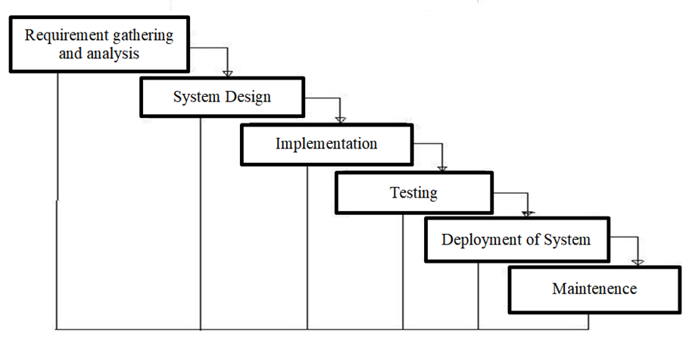

Fig (3.1): Waterfall model.

Requirement Identification
Requirement identification is the gathering of relevant requirement that will be used to develop a system. Different methods has been adopted to gather requirement for this project.

3.1.1.1.1 Functional Requirements
Only admin can log in to the system. Admin can manage doctor profile, cancel or approved the appointment. Admin can view(total new appointment, total approved, cancelled appointment, total appointment). Users can view the web page of application and can send the request for the appointment. Users can also choose the doctor according to their health issues.

3.1.1.2 Non-Functional Requirements
DAMS will provide reliability, economic and security. This website will allow multiple users to book an appointment .As it allow the doctor login system and it allows doctors to logout after finish to check the appointment detail.

Feasibility Study
It is the study of how well the system will function under the given constraints. It studies about how easy is it to build a system under given constraints. The constraints include operational feasibility, economic feasibility, and technical feasibility.

Technical Feasibility
This system meets the technical feasibility as it will be using existing technologies like HTML, CSS, JavaScript, PHP and MYSQL etc. as well as simple hardware specifications.

Operational Feasibility
Since the system promises to provide easier and understandable user interface as well as responsiveness when used in another device. Thus, the proposed system will be operationally feasible.

Economic Feasibility
The system will be feasible economically as the only resources needed will be a laptop, internet connection and electricity.

Data Modeling

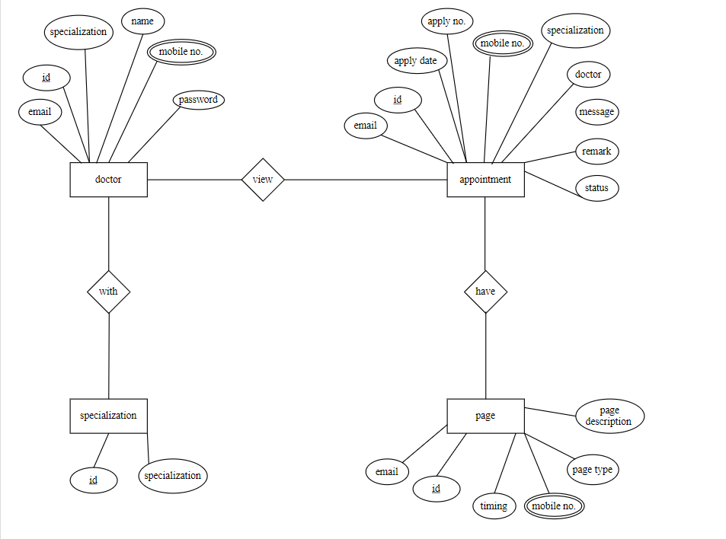

Fig 3.2: ER-Diagram of DAMS

Process Modeling
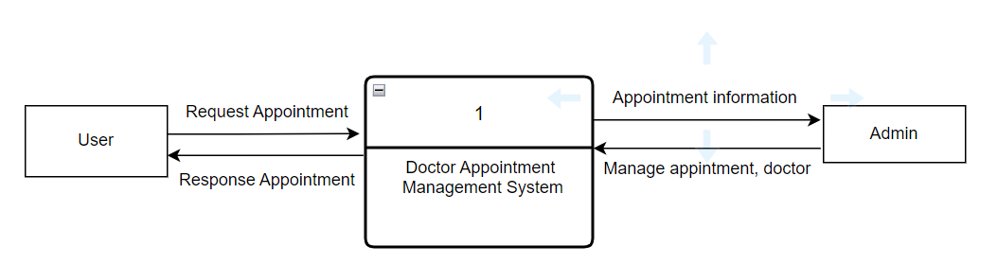
Fig 3.3: Concept diagram of Video Sharing Platform

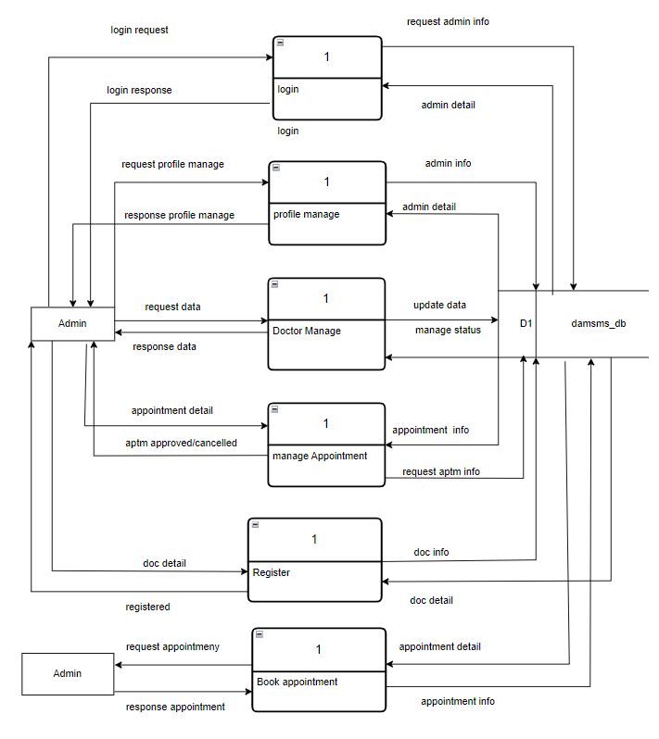
Fig 3.4: DFD level-0 of DAMS

Use-Case Diagram for User and Admin:

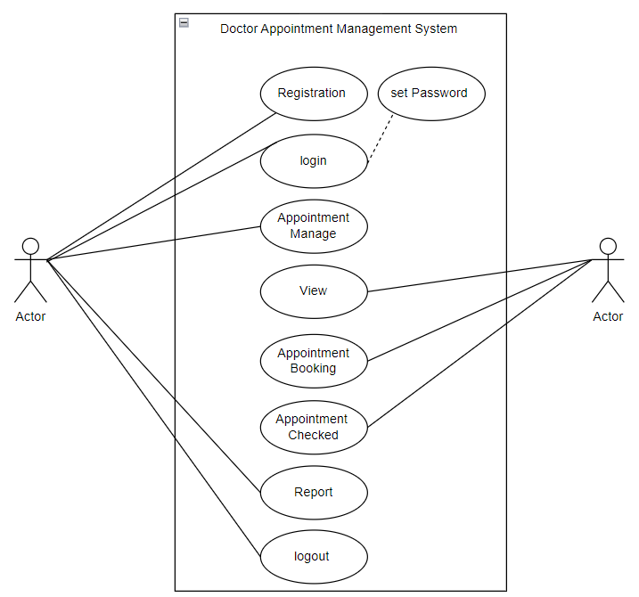
User
Admin

Fig 3.5: Use case diagram of DAMS.

Flow Chart for Admin:

Start
Insert Username and Password
Invalid
Admin Authentication
No
Yes
Valid

Fig 3.6: Flow Chart for DAMS
Insert, cancel, approved, view appointment
Stop
Admin Home Page

System Design

Architectural Design

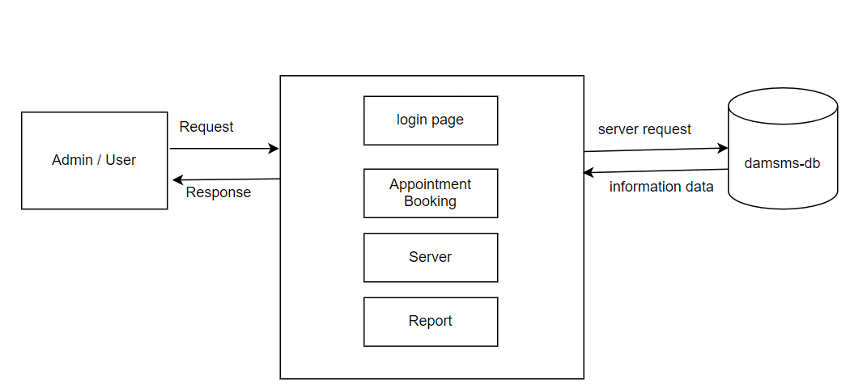

Fig 3.7: Architectural design of DAMS

Database design schema

Table 3.1: tblappointment

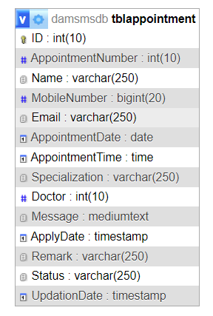

Table 3.2: tbldoctor

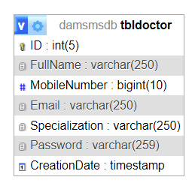

Table 3.3: tblspecialization

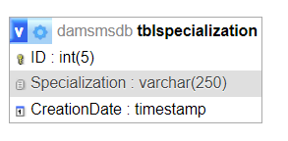

Table 3.4: tblpage
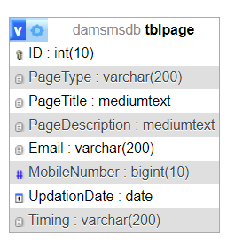

Chapter 4: Implementation and testing

Implementation

Tools Used Frontend:
- HTML
- CSS
- JavaScript
- Jquery
- Ajax

Backend:

- PHP

Database:

- MySql

Server:

- Apache
Language used:
- PHP5.6, PHP7.x

Implementation details of modules
The different modules provided are:

Doctor Module :

- Dashboard: In this section, the doctor can briefly view the total number of new appointment, total approved appointments and total canceled appointments.
- Appointment: In this section, the doctor views the appointment details and they have also the right to change application status according to the current status.
- Reports: In this section doctor can view the appointment details in a particular period.
- Search: In this section, doctor can search appointments with the help of user appointment number/Name/Mobile Number
User Module :(User does not need to register)

- Home Page: In this section, user can view the welcome page of the web application.
- Book: In this section, user can sent the appointment request.
- Check Appointment: In this section, user can search appointment with the help of user appointment number/Name/Mobile Number.

Testing

Testing cases for unit testing
Testing case for unit testing of login and logout system

Table 4.1: Test cases of unit testing for login and logout operation

Test case(s) | Steps | Expected results | Status
1. | Enter a valid email and password. Then press the login  button. | The admin go to the admin Pannel | Pass
2. | Click register button | The user should be  redirected back to the login page | Pass
3. | Do not fill any field | The program should display an alert box mentioning the blank  fields. | Pass
4. | Press sign out button. | The user should be redirected to index  page | Pass

Testing case for unit testing of admin page

Table 4.2: Test cases of unit testing for admin operation

Test case(s) | Steps | Expected results | Status
1. | Login as an admin | The user should be redirected to admin  dashboard | Pass
2. | Click on registration | The information should store in database | Pass
3. | Press appointment | The admin can check total appointment, cancelled appointment, approved appointment | Pass
4. | Press on profile | The admin can update or reset profile | Pass
5. | Press search | Seach the appointment by mobile number, name, appointment number | Pass
6. | Press report | Shows the date report of appointment | pass
7. | Change password | Admin should change or reset the password | pass
8. | Press new appointment | Admin can add new appointments | pass

Testing case for System testing
Table 4.3: Test cases of System testing

Test case(s) | Steps | Expected results | Status
1. | Press on booking | User can book an appointment and submitted | Pass
2. | Click on contact | The user should be contact to the clinic for the detail information | Pass
3. | Click on check appointment | After the user book an appointment they can also check the appointment if it is approved or not | Pass
4. | Click on doctor | Goes on login to enter on dashboard | Pass

Chapter 5: Conclusion and future recommendation

Lesson learnt/ outcome
The project will allow users to view the home page and can book an appointment any time they want. It provides multiple doctor with their specializations . User can fixed their appointment to the doctor at any time. The users can also leave the additional message .

Conclusion
In short, the Doctor Appointment Management System (DAMS) is a game-changer for both patients and healthcare providers. It makes scheduling appointments easy and convenient, reduces missed appointments, and helps clinics run more smoothly. While there are still some challenges to overcome, DAMS is making a big difference in how healthcare appointments are managed. It's a win-win for everyone involved, making healthcare more accessible and efficient.

Future Recommendations
DAMS can further be enhanced by providing continuously update the system to make it even easier for patients to book appointments and for healthcare providers to manage their schedules. Make DAMS available in multiple languages and ensure compatibility with a wide range of devices to improve accessibility for all users.

Screen Shots of output:

Appendices



Fig 1: Home Page

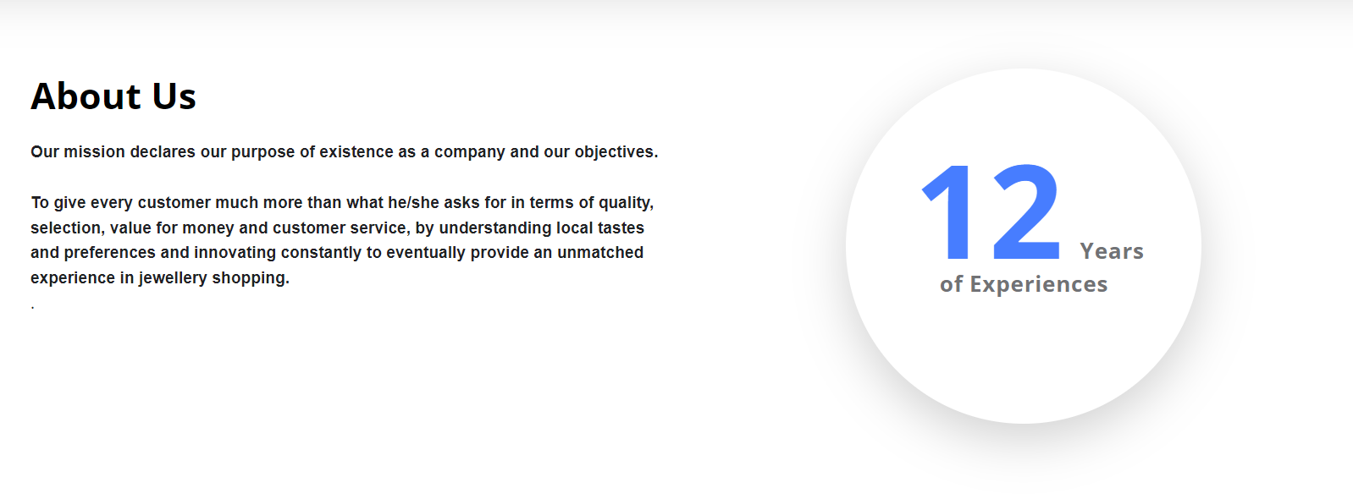

Fig 2: About us Page

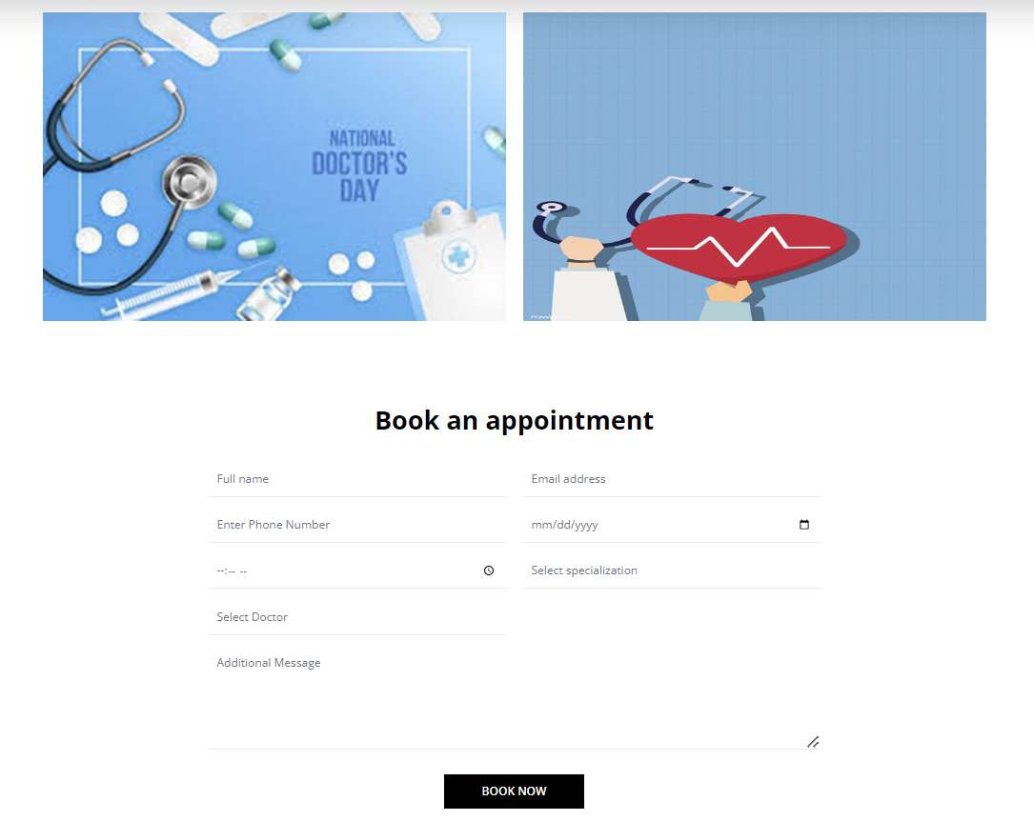

Fig 3: Booking an Appointment Page

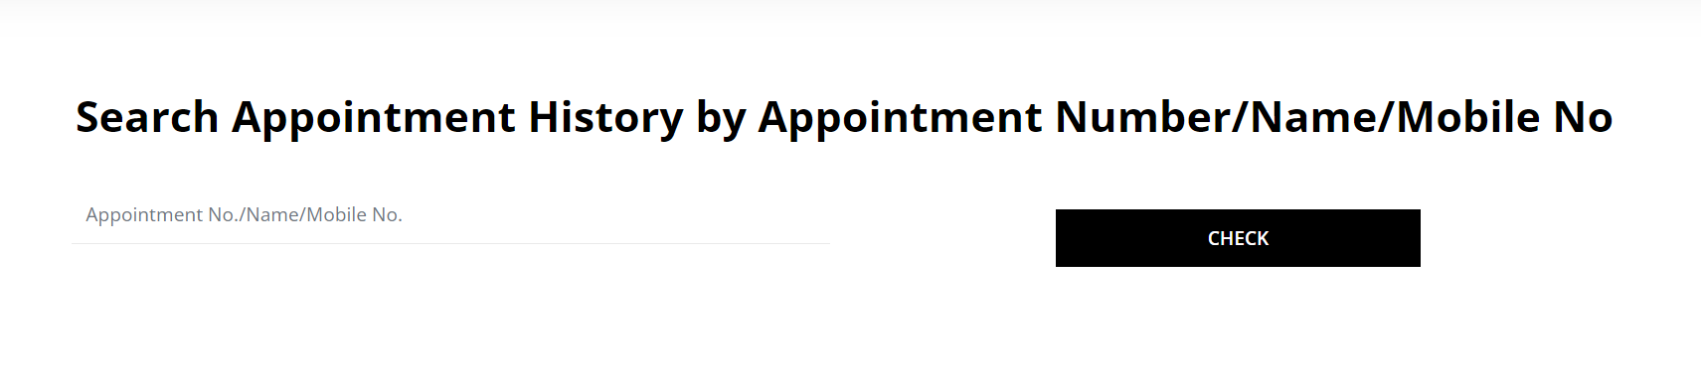

Fig 4: Checking Appointment Page

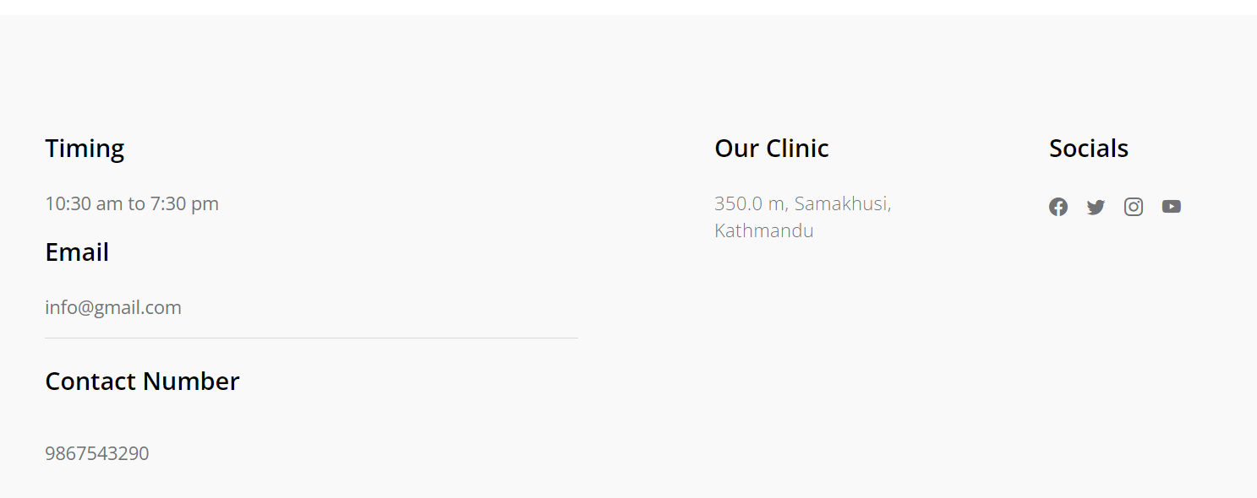

Fig 5: Contact Page

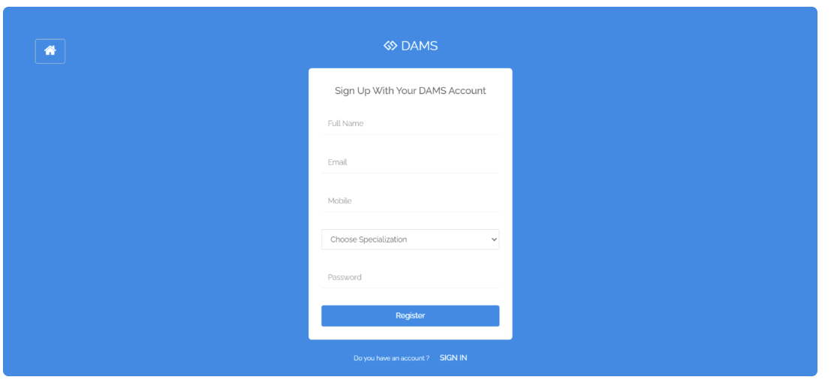

Fig 6: Doctor Signup Page

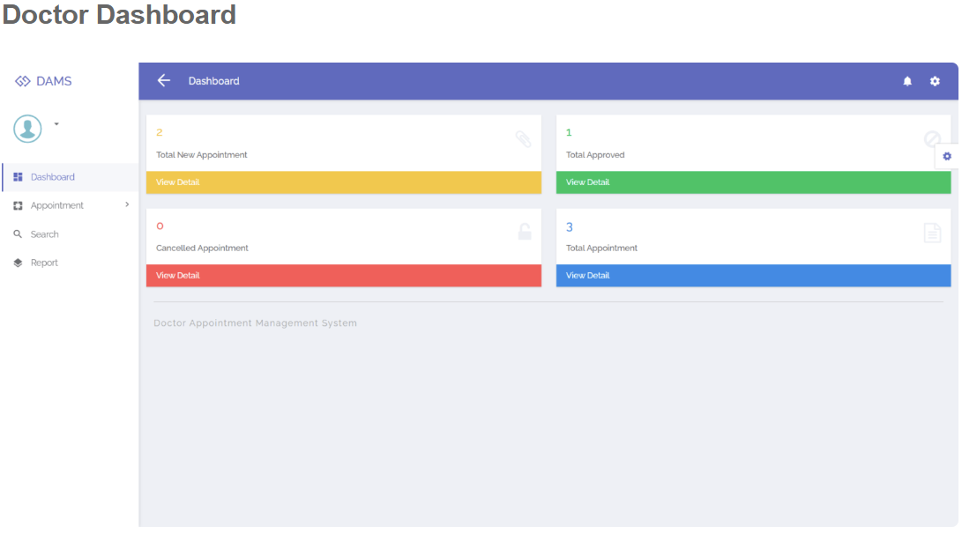

Fig 7: Admin Home Page

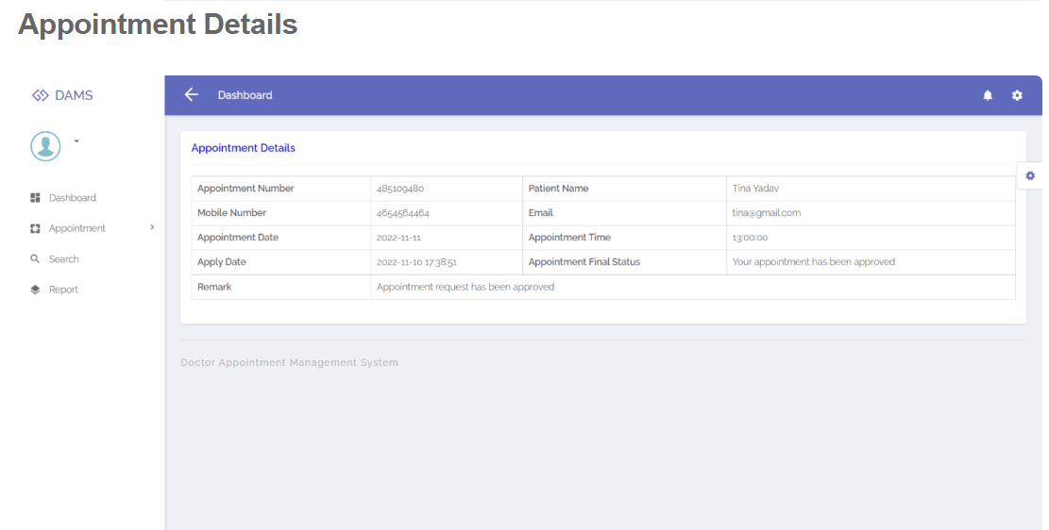

Fig 8: Appointment Detail Page

References

(1) https://www.youtube.com/watch?v=j5l_ILzDVH8&t=153s

(2) https://www.youtube.com/watch?v=keNKo3lhHVg

(3) https://www.irejournals.com/formatedpaper/1703874.pdf

(4) https://dl.ucsc.cmb.ac.lk/jspui/bitstream/123456789/4321/1/2015MIT057.pdf

